Facing Pelvic Pain
TREATMENT MAP

This tool will allow you to communicate and map treatment over time. Your health care providers can use this information to understand your diagnosis and to plan future treatments. This document is based on official guidelines as well as multidisciplinary provider experience.
My primary symptoms are:

Special considerations I wish to communicate (exam anxiety, gender, requests):

Timeline and story of symptoms:

I Have the Following Conditions: | Yes | Suspected | No
Pelvic Conditions:
Pelvic/ lower abdominal pain
Urethra and bladder pain:
□ Pain as my bladder fills with urine that is relieved by
urination
□ Pain during urination
□ Pain that worsens after urination
□ Pain on the skin / vulva / tip during urination
Perineum (bicycle seat) pain
Vulvar/ vaginal pain
Clitoral pain or unwanted arousal
Testicular/ penile pain
Anal/ rectal pain (incl. pain with bowel movement)
Pain with sitting relieved by standing
Lubrication or erection trouble
Sexual pain
Pain with menses
Endometriosis
Irritable bowel syndrome
Pelvic floor muscle dysfunction
Recurrent urinary tract infections
History of sexually transmitted infection
Pelvic cancer
Urinary incontinence
Bowel incontinence
Constipation
Blood in the stool
Pelvic organ (bladder, rectum, uterus) prolapse
Prostate problems
Difficulty starting urine stream
Incomplete emptying of the bladder
Urinary urgency, frequency, nighttime urination
Blood in the urine
Neurogenic bladder or bowel
Balance problems or leg or arm weakness
Varicose veins on legs buttocks privates
Other pelvic conditions:
Conditions Affecting other Areas of the Body: | Yes | Suspected | No
GERD (heartburn)
Migraines
Fibromyalgia
TMJ (jaw pain)
Nerve pain – spine or back, or sciatica
Nerve pain – peripheral e.g. sensitive feet
Loss of hair on extremities
Palpitations (rapid heat beat)
Ringing in the ears
Asthma or respiratory problems
Nausea
Dizziness
All over body pain or joint pains (where?)
Vision Changes
Depression or anxiety
History of sexual abuse or other trauma
Dependence on medication alcohol or drugs
Other Medical Problems or Surgical History: | Year of Diag | Doctor | Comments
Please mark ALL areas on the body maps (not just the pelvis) where you have had pain in the last week.
Area # or letters | Left Right or Center | No  Pain  0 | 1 | 2 | 3 | 4 | 5 | 6 | 7 | 8 | 9 | Pain as bad as you can imagine  10
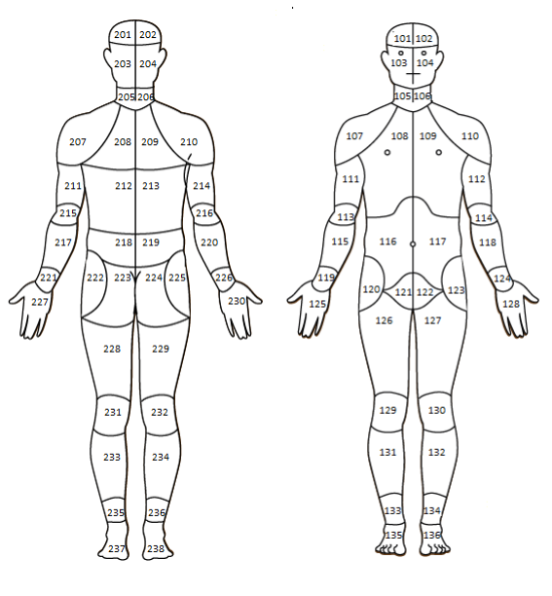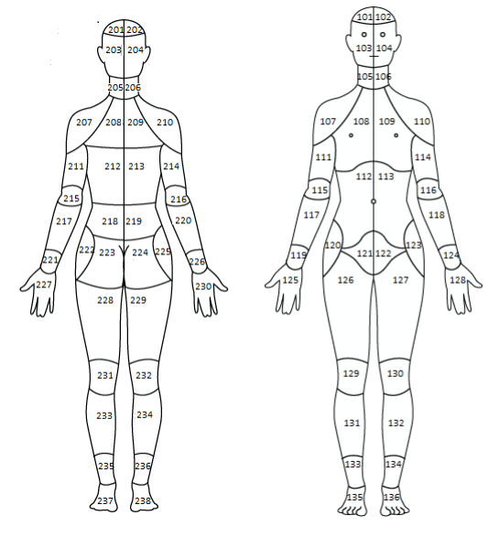
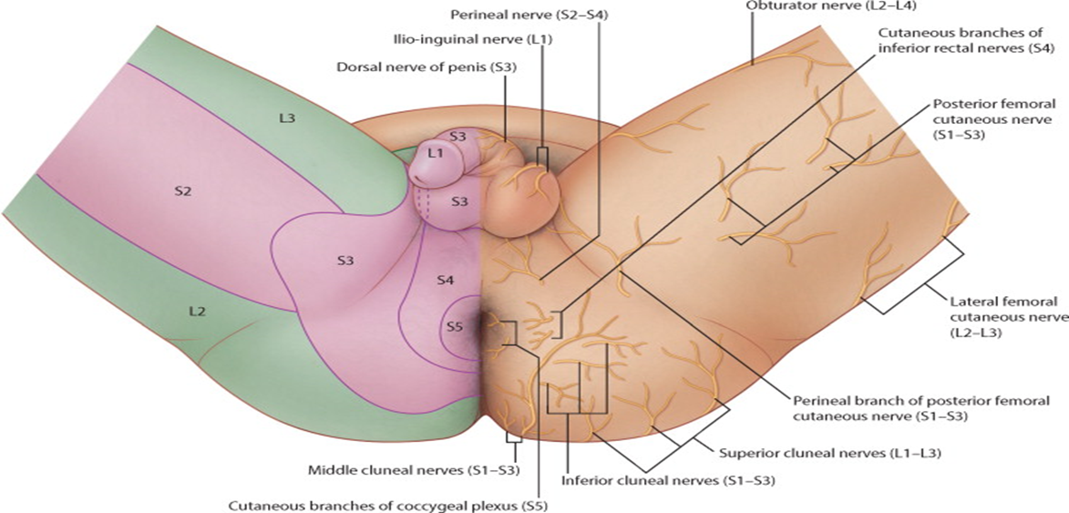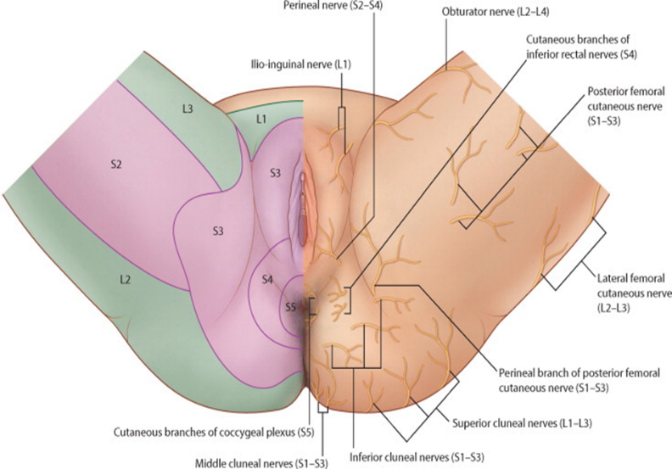
MAPPII Interactive CHOIR Body Map https://choir.stanford.edu
Gray's Atlas of Anatomy. Drake et al. Pages211-289. © 2015.
Dermatomes and cutaneous nerves of perineum in men.
Gray's Atlas of Anatomy. Drake et al. Pages211-289. © 2015.
Dermatomes and cutaneous nerves of perineum in women.
Prior Medications Tried:
Bladder Relaxing Medications | Tried? | Relief? | Still Using?
Oxybutynin (Ditropan®)
Oxybutynin Gel (Gelnique®) transdermal sachet daily
Oxybutynin Transdermal Patch (Oxytrol®) over counter
Tolterodine (Detrol®)
Fesoterodine (Toviaz®)
Trospium (Sanctura®)
Darifenacin (Enablex®)
Solifenacin (Vesicare®)
Mirabegron (Myrbetriq®)
Hyoscyamine (Levsin®)
Medications to Open Bladder Outlet
Terazosin (Hytrin®)
Tamsulosin (Flomax®)
Doxazosin (Cardura®)
Alfuzosin (Uroxatral®)
Silodosin (Rapaflo®)
Bladder Pain Medications
Pentosan Polysulfate Sodium (Elmiron®)
Phenazopyridine (Pyridium®)
Amitriptyline (Elavil®), Nortriptyline (Pamelor®)
Uribel® (methenamine, sodium phosphate monobasic, phenyl salicylate, methylene blue, and hyoscyamine sulf)
Allergy Medications: Hydroxyzine (Atarax®) Diphenhydramine (Benadryl® Genahist®, Sominex®, Unisom®), Cimetidine® (Tagamet®), Cetirizine hydrochloride (Zyrtec®), Fexofenadine (Allegra®), Loratidine (Claritin®)
Bladder instillations (heparin, lidocaine, sodium bicarbonate, antibiotic)
Bladder instillation (Dimethyl sulfoxide, DMSO/Rimso-50®)
Cyclosporine A (Gengraf®, Neoral®, Sandimmune®)
Infection Management | Tried? | Relief? | Still Using?
Oral or IV Antibiotics (doses and # days)

Proanthocyanidins (Ellura®, Theracran®) or other cranberry extract
D-Mannose
Methenamine (Hiprex®, Mandelamine®, Urex®)
Probiotics
Antibiotic Instillation in the Bladder
Other:
Vulvar / Vaginal Treatments | Tried? | Relief? | Still Using?
Avoidance of Irritants (select toilet paper, soap)
Vaginal creams, ointments, etc.:
□ Barrier cream/ointment (type):zinc oxide, dimethicone, petroleum)
□ Estrogens (commercial or compounded)
□ Anti-yeast/antifungal agents
□ Antibacterial agents for bacterial vaginosis
□ Steroid (clobetasol, hydrocortisone)
□ Diazepam (Valium®) vaginal Suppositories
□ Baclofen (Lioresel®)
□ Lidocaine
□ Gabapentin (Neurontin®)
□ Amitriptyline (Elavil®)
□ Tacrolimus (Prograf®)
□ Naltrexone - low dose (Vivitrol®)
□ Douches
□ Other Inserts
□ Wipes
Hormonal Medications | Tried? | Relief? | Still Using?
Vaginal estrogen cream, tablet or ring
Estrogen / progesterone pills or patches
Hormone-secreting intrauterine device (Mirena®, Liletta®, Skyla®)
Medroxyprogesterone acetate (Depo-Provera®) injection
Etonogestrel (Nexplanon®) progesterone implant
Aygestin (northindrone)
Elagolix (Orilissa®)
Leuprolide Acetate (Lupron Depot®)
Aromatase inhibitors:
-Anastrozole (Arimidex®)
-Letrozole (Femara®)
Testosterone injections or implants
Testosterone applied to skin (Testim®, Androgel®)
Specific Penile/ Testicular Pain Medications | Tried? | Relief? | Still Using?
Penile injection medications for pain - Collagenase clostridium histolyticum (Xiaflex®)
Other
Anorectal Pain Medications | Tried? | Relief? | Still Using?
Sitz bath
Barrier cream/ointment:e.g. zinc oxide, corn starch, dimethicone, petroleum
Wipes
Loperamide (Imodium®)
Sphincter relaxing ointments: nifedipine or diltiazem (calcium channel blockers) and glyceryl nitrate (GTN)
Lidocaine numbing gel or cream
Anti yeast creams, ointments or oral medications
Agents to soften stool: Docusate sodium (Colace®), Psyllium (Metamucil®) or other fiber
Agents to bulk stool: Psyllium (Metamucil®) or other Fiber
Immune and Anti-Inflammatory Medications | Tried? | Relief? | Still Using?
NSAIDs: Ibuprofen, Celecoxib, Diclofenac, Indomethacin , Naproxen, Oxaprozin, Piroxicam
Mesalamine (Pentasa®, Asacol®, Apriso®, Delzicol®, Lialda®)
Steroids
Immunosuppressants: Azathioprine (Azasan®, Imuran®), Remicade (Infliximab®), Ustekinymba (Stelara®), and
Monoclonal antibodies: Humira (Adalimumab®), Vedolizumab (Entyvio®)
Immunomodulators
Interleukins (IL-1, IL-17)
Tumor necrosis factor alpha TNF-α
IV immunoglobulin (IVIG)
General Pain Medications | Tried? | Relief? | Still Using?
Acetaminophen (Tylenol®)
Carbamazepine (Tegretol®)
Gabapentin (Neurontin®)
Pregabalin (Lyrica®)
Topiramate (Topamax®)
Fluoxetine (Prozac®)
Duloxetine (Cymbalta®), Lamotrigine (Lamictal®), Oxcarbazepine (Trileptal®), Lacosamide (Vimpat®), Venlafaxine (Effexor®), Milnacipran (Savella®), Sertraline (Zoloft®)
Amitriptyline (Elavil®)
Nortriptyline (Pamelor®)
Imipramine (Tofranil®)
Opioids: Oxycodone (OxyContin®), Hydrocodone (Vicodin®), Codeine, Meperidine (Demerol®), Morphine (Roxanol®), Methadone, Hydromorphone (Dilaudid®), Tramadol (Ultram®), Fentanyl (Duragesic®, Onsolis®, Fentora®)
Oral Muscle Relaxants
Baclofen (Kemstro®, Lioresal ®)
Tizanidine (Zanaflex®)
Cyclobenzaprine (Flexeril®, Amrix®, Fexmid®)
Benzodiazepines (Valium®, Xanax®, Ativan®)
Blood Thinners
Aspirin
Clopidogrel (Plavix®)
Cilostazol (Pletal®)
Other Medications (list): | Tried? | Relief? | Still Using?
Surgery (cite hospital and surgeon, obtain op note): | Year: | Relief? | Details
Laparoscopy, fulgaration, or excision of endometriosis
Hysterectomy (removal of uterus)
Myomectomy (uterine fibroid removal)
Ovarian cyst removal
Ovary removal
Caesarian section
Prolapse surgery, vaginal or rectal (details):
Urinary incontinence surgery
Urinary incontinence injection (e.g. Collagen, Macroplastique®, Coaptite®)
Urethral diverticulum or fistula surgery
Cystoscopy (may include biopsy)
Urethral dilation
Bladder hydrodistension
Kidney stone surgery (shock wave or telescopic)
Prostate surgery
Testis surgery (including vasectomy)
Ejaculatory duct surgery
Bowel or rectal surgery
Anal surgery
Lysis of Adhesions
Sacral nerve stimulation (Interstim®)
Spinal stimulator (type and level if known)
Medication pump (e.g. baclofen or pain medication)
Release of nerve entrapment
Surgical denervation (cutting of nerves)
Back surgery
Hip, knee or foot surgery
Pelvic bone surgery
Blood vessel surgery
Botulinum toxin: OnabotulinumtoxinA (Botox®), RimabotulinumtoxinB (Myobloc®), AbobotulinumtoxinA (Dysport®) to:
□ Bladder detrusor muscle
□ Bladder exit (sphincter)
□ Pelvic floor muscles (trigger point)
□ Skin surface (e.g. vulva, scrotum)
□ Spermatic cord (nerves to testis)
□ Anal sphincter
□ Hip / leg muscle
□ Iliopsoas muscle
Other surgery:
Procedures and Treatments | Tried? | Relief? | Details
Acupuncture
Massage
Nerve blocks or injections (name nerves and what medication was used if known):
Pessary
PTNS
TENS Unit
Radiofrequency Ablation
Cryoablation (freezing) e.g. nerves of Spermatic Cord
Vaginal Laser Therapy
Blood vessel embolization or stenting
Emsella® Chair
Other Treatments
Bladder Management | Tried? | Relief? | Details
□ Bladder empties naturally
□ Timed voids by the clock
□ Intermittent catheterization __ times per day
□ Indwelling tube changed every __ weeks
□ Supply information:
Pelvic Floor Physical Therapy | Tried? | Relief? | Details
Pelvic Floor Physical Therapy in general (any type)
- Hands on work / joint and tissues mobilization
- Stretching or yoga exercises
- Aerobic exercises
- Strength exercises: abdominal, legs
- Biofeedback
- Body mechanics and posture training
- Physical Therapy focused on pain management
- Physical therapy for back, knees, hips, etc.
Lifestyle and Behavior Changes
Diet alteration to avoid irritants
Avoidance of Caffeine, Sweeteners, Tea
Fluid alteration to target 1500-2500 cc per 24 hours
Attention to seat surface and ergonomics at work, commute, home
Avoidance of vulvar or scrotal irritants
Counseling and Psychological Therapies | Tried? | Relief? | Details
Meditation, Relaxation Strategies
Any psychotherapy
Individual therapy
Cognitive behavioral therapy
Mindfulness-based therapy
Group therapy
Couples therapy
Formal Sex Therapy
Other:

Testing completed | Approx Date | Location/ Institution | Results
Urinalysis and Culture
Urine cytology
Urine Ureaplasma and Mycoplasma
Testing for genital infections
Pregnancy test
Blood tests
Stool Test
Completion of a Voiding Diary
Measurement of post void residual (PVR) urine volume (the amount remaining after urinating)
CT Scan of:
□ Spine
□ Head
□ Abdomen
□ Pelvis
Ultrasound of:
□ Abdomen
□ Kidneys
□ Pelvis
□ Scrotum/Vagina
□ Veins
MRI of:
□ Spine/ sacrum
□ Head
□ Abdomen
□ Pelvis
Spine Xray (type)
Pelvis Xray
Defacography (bowel movement under X-ray with dye)
Anal manometry (bowel movement with measurement of pressure in rectum)
Upper GI Study (X-ray after swallowing dye)
Cystogram, voiding cystourethrogram (VCUG), urethrogram (X-ray with dye in bladder or urethra)
Angiogram (X-ray with dye in artery)
Cystoscopy (small camera passed into bladder)
Ureteroscopy (small camera passed into ureter)
Urodynamic testing (pressure measurement during void)
Endoscopy (small camera passed into throat)
Colonoscopy / Proctoscopy / Sigmoidoscopy (small camera passed via anus)
Sitzmark Study (X-ray or beads passing through GI tract)
Laparoscopy (small camera passed into abdominal wall)
EMG (test of nerve response to stimulation)
Autonomic testing (tilt table testing)
Nerve biopsy (for small fiber polyneuropathy)
Other:

Types of Health Care Providers Seen: | Name | Location | Current provider?
□ Allergy
□ Cancer Medicine
□ Cardiology
□ Colorectal Surgery
□ Gastrointestinal Medicine
□ Gynecology
□ Infectious Disease
□ Neurology
□ Ophthalmology
□ Orthopedics
□ Pain Management
□ Physical Therapy
□ Primary Care
□ Psychology/ Psychiatry
□ Pulmonology
□ Rehabilitation Medicine (Physiatrist, PMR)
□ Rheumatology
□ Urology
□ Other

Current working diagnoses: | Details
□ Unsure of diagnosis
□ Bladder obstruction
□ Overactive bladder
□ Underactive bladder
□ Neurogenic bladder
□ Interstitial cystitis
□ Incontinence of urine
□ Recurrent urinary tract infections (UTIs)
□ Vulvar atrophy
□ Vulvodynia or chronic vaginitis
□ Endometriosis
□ Erectile dysfunction
□ Peyronie’s disease
□ Prostatitis
□ Pelvic floor muscle dysfunction
□ Prolapse
□ Constipation, diarrhea, IBD or IBS
□ Anal fissures or hemorrhoids
□ Incontinence of bowel
□ Neurogenic bowel
□ Nerve pain - spine
□ Nerve pain - peripheral nerves
□ Systemic pain syndrome
□ Autoimmune disease
□ Rheumatologic disease
□ Other:

Next Steps:

